3GPP TSG-RAN WG4 Meeting #119 R4-2606696
Dalian, China, May 18th – 22nd, 2026

Source: Nokia
Title: Discussion on 6G Sensing Use Cases and Modes
Agenda item: 8.10.2
Document for: Discussion
- Introduction
The discussion on 6G sensing started in RAN4#116bis meeting. The first agreements related to 6G sensing use cases and modes were reached in RAN4#118 [1].
Issue 1-2: Use case
- Reuse the definition of use case from TR 38.914 in Section 5.4.4:
  - “The 6GR and 6G RAN architecture shall at least support use cases of detection and/or tracking of passive objects, at least including UAVs, human, vehicles and AGVs”.
  - Update according to RAN decision, if there’s any, in the following plenaries.
Issue 1-3: Sensing mode
- Recommended WF:
  - To follow RAN and RAN1 agreement

In RAN4#118bis, new agreements were made on sensing modes and targets for 6G sensing feasibility and coexistence studies [2].
Issue 2-2: Use case and Issue 2-3: Sensing mode
Agreement for the scenarios (sensing modes and sensing target) for 6G sensing coexistence study from RAN4 work management perspective:
- UAV (passive object), TRP monostatic
  - FFS on Multiple TRP monostatic.
- Vehicle (passive object), TRP-UE bistatic
- [TBD] (passive object), UE-TRP bistatic
- UAV (passive object), TRP-TRP bistatic
RAN4 doesn’t preclude any 6G scenarios as agreed by RAN-P and RAN1;
Agreement for the feasibility study for 6G sensing:
- UAV (passive object), TRP monostatic
  - FFS on Multiple TRP monostatic.
- Vehicle (passive object), TRP-UE bistatic
- [TBD] (passive object), UE-TRP bistatic
- UAV (passive object), TRP-TRP bistatic
- In addition to above cases, other sensing modes/scenarios as agreed by RANP and RAN1 could be also studied.

In this contribution, we provide our views on the open items and FFS points related to the sensing modes and targets agreed in RAN4#118bis meeting for the 6G sensing feasibility and coexistence studies.
- Discussion
  - Views on “Multiple TRP monostatic”
In the agreement stated above from RAN4#118bis, there was an FFS on “Multiple TRP monostatic”. At this stage, it is not clear what this term exactly means. One potential explanation of using multiple TRPs can refer to the TRP-TRP multistatic sensing mode, as shown in the example in the right part of Figure 1. However, as it is mentioned under the TRP monostatic scenario, another potential explanation for this “Multiple TRP monostatic” is that multiple TRPs receive reflected signals from the same target in a monostatic way, as shown in the left part of Figure 1. Subsequently, the sensing signal processing in this case can be based on fusion of measurements from multiple TRPs. This was actually considered in the NR ISAC study as a technique to achieve the sensing performance objectives defined for the evaluation of the UAV detection use case with gNB-based monostatic sensing [3].
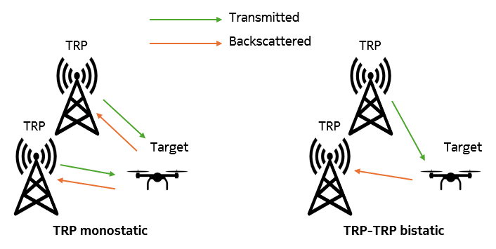
Figure 1: Example scenarios with multiple TRPs.
Fusion of measurements from multiple TRPs was considered in the NR ISAC study as a technique to achieve the sensing performance objectives defined for the evaluation of the UAV detection use case with gNB-based monostatic sensing.
Hence, we believe that RAN4 should first clarify the exact meaning of the term “Multiple TRP monostatic”, i.e., it just refers to TRP-TRP multistatic sensing mode or it refers to the sensing fusion concept assumed in the NR ISAC study.
- RAN4 to clarify the meaning of “Multiple TRP monostatic” compared to TRP-TRP multistatic sensing mode and sensing fusion considered in the NR ISAC study.
If it will be clarified that the “Multiple TRP monostatic” refers to the sensing fusion concept used in the NR ISAC study, we believe that RAN4 should start the 6G sensing feasibility and coexistence studies of the TRP monostatic scenario without considering sensing fusion aspects. These can be considered at a later stage of the study, e.g., to enhance the sensing performance or achieve some defined 6G sensing performance objectives.
- RAN4 to start the study of the TRP monostatic mode without considering sensing fusion aspects. These can be considered at a later stage of the study, e.g., to enhance the 6G sensing performance.

  - Sensing target for the UE-TRP bistatic scenario
In the agreement stated above from RAN4#118bis, a sensing target was agreed for the TRP monostatic, TRP-TRP bistatic, and TRP-UE sensing modes. However, the sensing target for the UE-TRP sensing mode was left TBD.
According to TR 38.914 [4], the possible sensing targets considered in the detection and/or tracking use case include UAVs, humans, vehicles, and AGVs. Detection of UAVs or vehicles is more relevant in outdoor scenarios, as considered in latest RAN1#124bis agreement on 6G sensing performance evaluation.
Agreement:
For Rel-20 6G sensing performance evaluation of object detection and/or tracking, the following cases/combinations are considered as baseline cases/combinations.
Sensing target | Indoor or outdoor | Scenario | Carrier frequency
UAV | Outdoor | UMa-AV, SMa | 4 GHz, ~7 GHz, 30 GHz (for UMa-AV only)
Human | Outdoor | UMa | 4 GHz, ~7 GHz, 30 GHz
 | Indoor | Indoor Hotspot | 4 GHz, ~7 GHz, 30 GHz
Vehicle | Outdoor | Urban Grid, Highway | 4 GHz, ~7 GHz, 30 GHz (for Urban Grid only)
AGV | Indoor | Indoor factory (SH) | 4 GHz, ~7 GHz, 30 GHz
- Note: sensing mode(s) for each row will be discussed
- Other cases/combinations can also be evaluated, reported and collected from companies.
- Note: In this agreement, no intention to de-prioritize other scenarios or carrier frequencies.

Similarly to considering UAV as the sensing target for both TRP monostatic and TRP-TRP bistatic sensing modes, RAN4 can consider vehicle as the sensing target for both TRP-UE and UE-TRP bistatic sensing modes. This may facilitate the comparison/alignment among these different scenarios, if needed under the 6G sensing feasibility and coexistence studies.
- RAN4 to consider vehicle as the sensing target for the UE-TRP bistatic scenario in the 6G sensing feasibility and coexistence studies.

- Conclusion
The following observations and proposals were made in this contribution:
Observation 1: Fusion of measurements from multiple TRPs was considered in the NR ISAC study as a technique to achieve the sensing performance objectives defined for the evaluation of the UAV detection use case with gNB-based monostatic sensing.
Proposal 1: RAN4 to clarify the meaning of “Multiple TRP monostatic” compared to TRP-TRP multistatic sensing mode and sensing fusion considered in the NR ISAC study.
Proposal 2: RAN4 to start the study of the TRP monostatic mode without considering sensing fusion aspects. These can be considered at a later stage of the study, e.g., to enhance the 6G sensing performance.
Proposal 3: RAN4 to consider vehicle as the sensing target for the UE-TRP bistatic scenario in the 6G sensing feasibility and coexistence studies.

References
- R4-2602286, “WF on 6G sensing”, ZTE Corporation, RAN4#118, February 09-13, 2026, Gothenburg, Sweden.
- R4-2605009, “Way Forward for [118bis][362] 6G_Sensing”, RAN4#118bis, April 13-17, 2026, St. Julian’s, Malta.
- TR 38.765 V1.0.0, “Study on Integrated Sensing And Communication (ISAC) for NR (Release 20)”.
- TR 38.914 V0.4.0, “Study on 6G Scenarios and Requirements (Release 20)”.

